RFID Reader Specification

Siemens RF382R Scanmode and

Siemens RF310R

Customer: Vistaprint Winterthur

Project: Line ALADDIN Shirt Stream and PROMO

Projectnr..: 10116.04.01

Version: 0.01

Storage: D:\01_Projekte\10116 Vista Print\04 Line - ALADDIN\01 Development\20_Engineering\20_Development\Specification\RFID Reader Spec V0.01.docx

# Table of contents

1 Table of contents 2

2 Introduction 3

2.1 Scope 3

2.2 Reference Documentation 3

2.3 Version 3

2.4 Abbreviations, definitions, glossary 3

3 Common information’s 4

3.1 Used software components and libraries 4

3.2 Important to know 4

3.3 Different RF ID Hardware 4

3.4 Open Points 5

4 Controller Description 6

4.1 Level 0 Element: RF ID Reader / Writter controller (Class RFW) 6

4.2 Data Structure 9

5 RF382R Scanmode 10

5.1 Driver Element: RFID Read only (Class RFR) 10

5.2 Test environment 11

5.2.1 Connections 11

6 RF310R Read and Write 13

6.1 Driver Element: RFID Read and Write (Class RFD) 13

6.2 Test environment 17

6.2.1 Connections 17

# Introduction

## Scope

This document gives an overview about the functions of controller RFW and RFR for controlling the Siemens RFID reader and is solely for the benefit of Vistaprint and all the persons that are involved at platform development. These are software developers, quality engineers and maintenance engineers.

## Reference Documentation

For RF382R Scanmode:

|  |  |  |
| --- | --- | --- |
| Documents | Version | Datum |
| RF382R_BAk_200910_de.pdf |  | 10.2009 |
| RFID Specification_v10-2013-08-19.docx | V10 |  |
|  |  |  |
| Beckhoff InfoSys - [EL6001](http://infosys.beckhoff.com/index.php?content=../content/1031/tcplclibhydraulics30/html/tchydlib_mc_bausteine.htm&id=) |  |  |
| Beckhoff InfoSys - [Serial Communication](http://infosys.beckhoff.com/index.php?content=../content/1031/tcplclibhydraulics30/html/tchydlib_mc_bausteine.htm&id=) |  |  |
|  |  |  |
|  |  |  |
|  |  |  |

For RF310R:

|  |  |  |
| --- | --- | --- |
| Documents | Version | Datum |
| Befehlstelegramme_RF300_V21.pdf | 2.1 |  |
| RFID Specification_v10-2013-08-19.docx | V10 |  |
| RF300_SHB_200911_en.pdf |  | 11.2009 |
| s7300_cp341_manual_de_de-DE.pdf (Protocol 3964R) |  | 04.2011 |
| 38471716_LibraryDescription_S7-1200_RFID_DOKU_V21_d.pdf (as example) |  | 05.2011 |
| 34392683_RF300_at_ET200S_d | V1.1 | 02.2013 |
|  |  |  |
| Beckhoff InfoSys - [EL6001](http://infosys.beckhoff.com/index.php?content=../content/1031/tcplclibhydraulics30/html/tchydlib_mc_bausteine.htm&id=) |  |  |
| Beckhoff InfoSys - [Serial Communication](http://infosys.beckhoff.com/index.php?content=../content/1031/tcplclibhydraulics30/html/tchydlib_mc_bausteine.htm&id=) |  |  |
|  |  |  |
|  |  |  |

## Version

|  |  |  |  |  |
| --- | --- | --- | --- | --- |
| Description | Author | State | Version | Date |
| Start | AVME/PRE | d | 0.1 | 2014-01-28 |
|  |  |  |  |  |
|  |  |  |  |  |
|  |  |  |  |  |
|  |  |  |  |  |
|  |  |  |  |  |
|  |  |  |  |  |
|  |  |  |  |  |
|  |  |  |  |  |

State: **d** = design, **r** = released

## Abbreviations, definitions, glossary

|  |  |
| --- | --- |
| Designation | Name |
|  |  |
|  |  |
|  |  |
|  |  |
|  |  |
|  |  |
|  |  |
|  |  |

# Common information’s

## Used software components and libraries

|  |  |  |
| --- | --- | --- |
| Description | Version | Datum |
| Beckhoff Tc2_SerialCom | 3.3.0.0 |  |
|  |  |  |
| TwinCAT TCP/IP connection server library (Tc2_TcpIp) | V3.3.1.0 |  |
|  |  |  |
|  |  |  |

## Important to know

The maximum effective data transfer rate depends in part on the PLC cycle time. Because of this the RF ID Driver has to run minimal in 2ms task cycle.

(See: <http://infosys.beckhoff.com/english.php?content=../content/1033/tcplclibserialcom/html/tcplclibsercom_concept.htm&id=20784>)

## Different RF ID Hardware

At Vista Print are used different Hardware for RFID read and write. At Promo a standard Siemens RFID Reader is used, type RF310R. With this, you could read and write RFID’s.

At Textile, only the RFID Tag serial number is used. For this, they use a special RFID Reader from Siemens; which is produced specially for Kannegieser, TypRF382R Scanmode.

This RFID Readers are very different. However, the SW only want to use a RFID Reader. Because of this there is used a RFID Driver, which has to be the correct one to the used Hardware (RF310R needs RFD, RF385R Scanmode needs RFR). The elementcontroller is the same and could communicate to both RFID Drivers.

RFW

Element controller

Driver organisation

Job Interface for CMD and State Data management

Array of 255 Byte for Data

RFD

Driver for RF310R

RFR

Driver for RF382R

only Scanmode => only read Read and write access

fix Tag ID All Data access

FB_Com_3964R

FB_ExCom

Serial communication to IO Point Serial communication to IO Point

using protocol 3964R

## Open Points

At starting Up the settings of the HW wanted to be written by SDO commands in the initialisation sequence to set the Datarate and other settings. For this the Net ID and Slave Address of the hardware is in the configuration. Because there where problems with this SDO writing, the settings are done in the Hardware interface in the startup date of the IO card. The Net ID and Slave Address is not needed now.

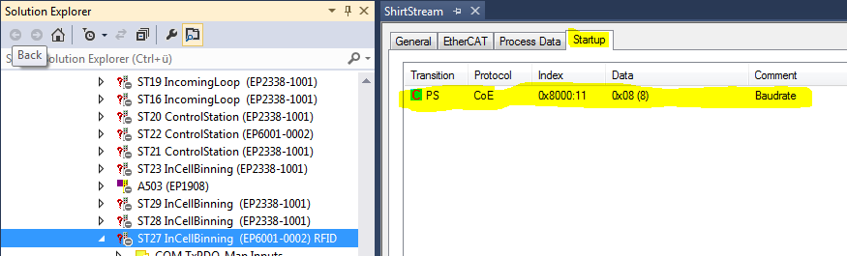

Figure 1: Startup settings example for HW Settings

# Controller Description

## Level 0 Element: RF ID Reader / Writter controller (Class RFW)

**Functionality**

Reads or writes RFID Tags over the serial interface.

In RUN State the RFID Element reads automatically the RFID Tag ID and save it in the current data.

As interface to the hardware a driver is needed. This depends on the used hardware.

**RUN Sequence**

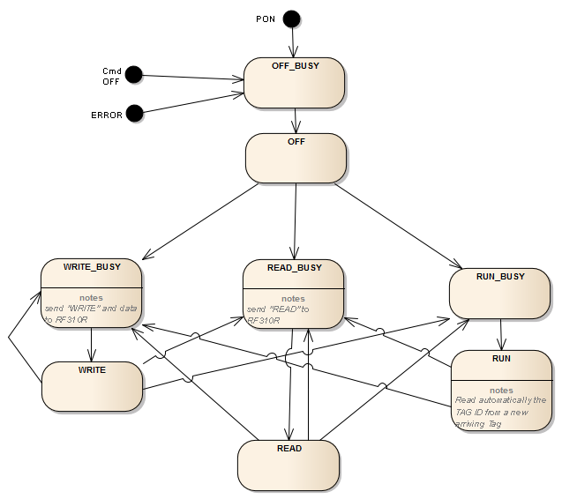

**Commands**

* OFF (Turn off antenna)
* READ (Read Data from RFID Tag, Start Address and Length for access in current data dwoJob)
* WRITE (Write Data to RFID Tag, Start Address and Length for access in current data dwoJob, data in Byte array)
* RUN (Read the RF Tag ID if a Tag is in the antenna area)

**Configuration**

|  |  |  |
| --- | --- | --- |
| *Variable* | *Datatype* | *Description* |
| eTyp | E_Typ_RFW | 0 = RF310R with Protocoll 3964R  1 = RF382R Scanmode (only Read) |
| bolGetTrayIDAuto | BOOL | Get the Tray ID too in RUN State (not only Tag ID) |
| bolDtChToLine_send | BOOL | Send every New RFID to Line Controller |
| stNetId | T_AmsNetID | Net ID of the EtherCat Master |
| uinSlaveAddr | UINT | Port Number of the EtherCat Slave Communication Module |

**Parameter**

|  |  |  |
| --- | --- | --- |
| *Variable* | *Datatype* | *Description* |
| udiReadTime_ms | UDINT | [ms] Timeout read data from RFID |
| udiWriteTime_ms | UDINT | [ms] Timeout write data from RFID |
| udiMinCmdTime_ms | UDINT | [ms] minimum waiting time between two read command |

**Current Values**

|  |  |  |
| --- | --- | --- |
| *Variable* | *Datatype* | *Description* |
| bolPresent | BOOL | Tag is present in the antenna area |
| abytData | ARRAY[0..255] of Byte | Data interface to Driver (Driver reads with pointer) for read and write Data |
| stData | T_RFW | RFID Data from RFID specifications |
| dwoJob | DWORD  See: RFID_Data | Word 1 Adress on the RFID to Read  Word 2 Length of data to access  Example: cRFID_TagID = 16#8FFF0 => 8 Byte from Adress 16#FFF0 |

**Errors**

* Communication Error to RFID Reader/Writer category: STOP
* Function Error from RFID Reader/Writer category: STOP
* Data Error category: STOP
* Timeout function category: STOP
* Function with this RFID Reader not possible category: STOP

**DataChannel to Line Control**

Send all ID with the new RF Tag ID

Data type for commuinication:

T_NewRfid_DtChn

uliTagID: ULINT;

strID: STRING; (depending on cfg Tray ID or Tag ID)  
 strTimestamp: STRING;

intDataState: INT;

**IO**

* No physical input/outputs

The Inputs and Outputs are connected at the Drivers. Directly from the Functional Block. Because this is in both types the same, it is here descriped.



Figure 2: Variable from Type Serialcomunication as free Inputs / Outputs

Then the Inputs and Outputs are connected to the correct hardware.

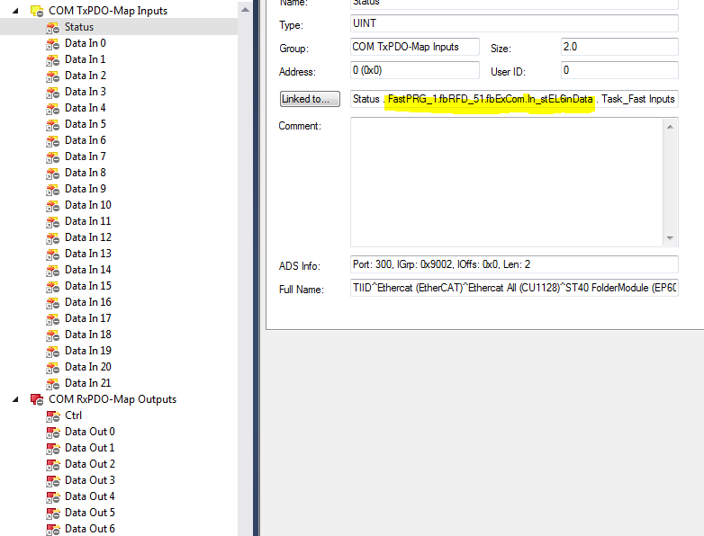

Figure 3: FB IO directly connected at the Hardware

## Data Structure

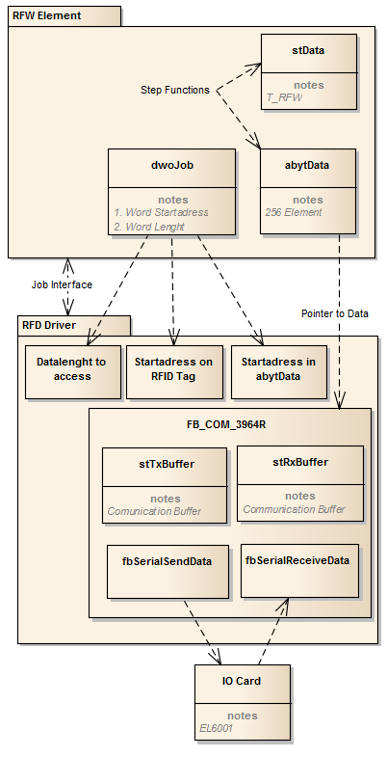

The stData is made similar to the RFID Specifications from Promo Platform (see “RFID Specification_v10-2013-08-19.docx”).

# RF382R Scanmode

## Driver Element: RFID Read only (Class RFR)

**Functionality**

The RF382R Scanmode RFID Reader is a special product for Kannegiesser. This Antenna reads automatically the Tag ID from a Tag in the antenna area and send this Tag ID as a string over the RS232 interface to the PLC. (For example send: E00801D7E553493A. This is the hexadecimal value of the Tag ID).

**Main Sequence**

Only stays in Wait for job. In CycleStartDuty the read Data is written into Data from RFW.

**Commands**

* PowerOn (Restart Communication)

**Configuration**

The configuration data structure is not needed now. Important settings are done with Startup data at the HW Card.

The configuration of the RF382R Antenna could be set with a special tool (in Folder “RF382R Parametrierung”). The possible settings are descriped in the manual “RF382R_BAk_200910_de.pdf” on page 9. Because we normally use the standard settings, the parameter where not downloaded in the power on state.

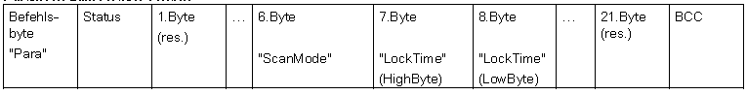

**ScanMode:** 00=ContinousRead, 01=Single Read (Read Tag only once)

**LockTime:** factor from 100ms to not read a Tag twice in ContinousRead

**Current Data**

|  |  |  |
| --- | --- | --- |
| *Variable* | *Datatype* | *Description* |
| pData | Pointer | Pointer to the Data in the Element controller |
| uinAdressData | UINT | Startadress to access in the Data array (Read and write does not have to be from 0) |
| uinAdressTag | UINT | Startadress to access on the RFID Tag |
| usiCount | USINT | Number of bytes to access |

## Test environment



### Connections

Pin at RF385R

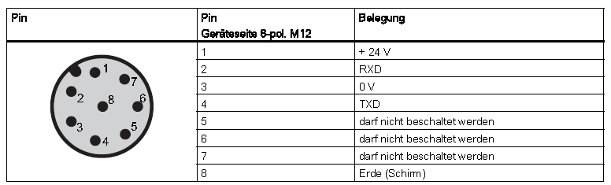

Cable color

white

brown

green

yellow

shild

Pin at serial communication Card EP6001

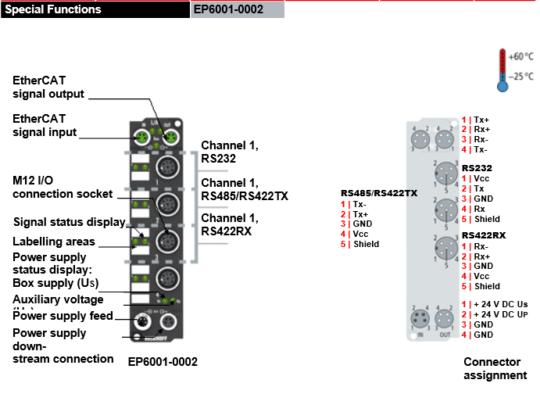

(see: <http://www.beckhoffautomation.com/english.asp?certifications/ethercat_box.htm?id=74598397303182150>)

# RF310R Read and Write

## Driver Element: RFID Read and Write (Class RFD)

**Functionality**

The RF310R RFID Reader is a Siemens Antenna with the possibility to read or write data on the RFID Tag. To communicate to the reader there is needed the protocol 3964R (A safety layer 2 over the bittransfer layer 1). This protocol could be implemented as a library in the Beckhoff TwinCat (TS6341 TwinCat PLC Lib: Serial Comm 3964R/RK512). Because we did not know if this library is working with the used hardware, we programmed this self in the function block FB_Com_3964R. The description on this interface in the document “s7300_cp341_manual_de_de-DE.pdf” Page 33ff.

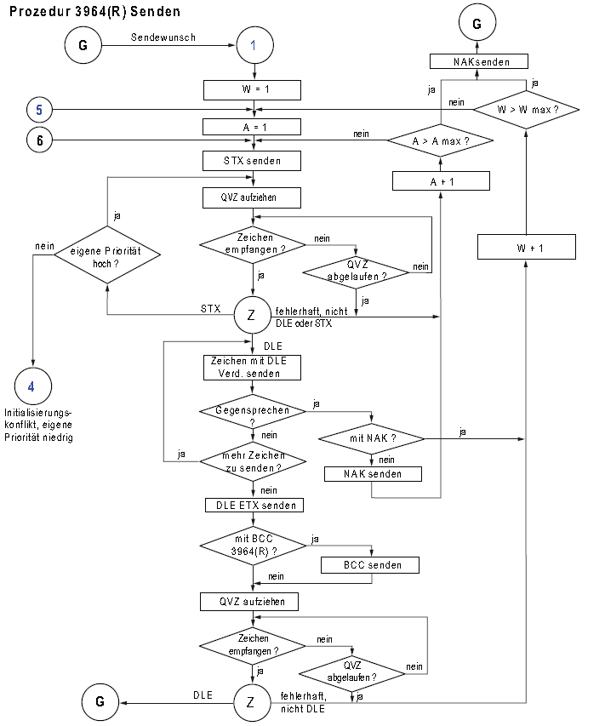

Figure 4: Sending cycle with 3964R Protocoll

The RFID Readers needs special commands which are described in the manual “Befehlstelegramme_RF300_V21.pdf”.

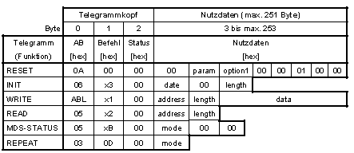

**Main Sequence**

Work on the job from Element controller. If no Job is ready, WaitForJob.

**Commands**

* CTRL_ON (Restart Communication)
* Read (Read Data from RFID Tag, Adress and length from current data)
* Write (Write Data to RFID Tag, Adress and length from current data, Data to write from pointered Byte Array)
* MDS get RFID Tag information
* SLG get antenna information
* OFF Turn off antenna
* CheckBusy Check the connection to antenna

**Configuration**

Hardwaresettings are done with Startup data at the HW Card.

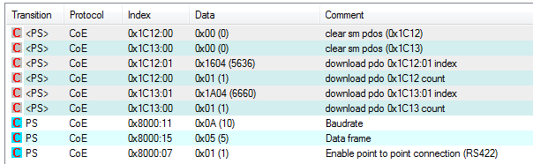

**Configuration**

|  |  |  |
| --- | --- | --- |
| *Variable* | *Datatype* | *Description* |
| usiResetParameter | USINT | Not used now, use fix 16#25 as initialisation value |
| usiFtimSetting | E_Typ_Ftim | Not used now |
| usiResetOption1 | USINT | Not used now |
| udiRetry | UDINT | Count Retrys for a RFID Job |

**Current Data**

|  |  |  |
| --- | --- | --- |
| *Variable* | *Datatype* | *Description* |
| pData | Pointer | Pointer to the Data in the Element controller |
| uinAdressData | UINT | Startadress to access in the Dataarray (Read and write does not have to be from 0) |
| uinAdressTag | UINT | Startadress to access on the RFID Tag |
| usiCount | USINT | Number of bytes to access |

**State**

|  |  |  |
| --- | --- | --- |
| *Variable* | *Datatype* | *Description* |
| bolStartupOK | BOOL | 1 = Antenna is initialized |
| bolInitOk | BOOL | 1 = Initialisatzion is done sucessfully |
| bolOn | BOOL | 1= Antenna is on |
| bolPresent | BOOL | Tag is in the antenna area |
| bolL_UEB | BOOL | Communication to SLG is tested ok |
| stSLG_State | T_RFD_SLG_STATE | State of the Antenna (only actual after SLG cmd) |
| stSLD_Diag | T_RFD_SLG_Diagnose | Diagnose information of the antenna (only after CMD) |
| stMDS_State | T_RFD_MDS_State | State of the Tag in the area (only actual after CMD) |
| stMDS_Diag | T_RFD_MDS_Diagnose | Diagnose information of the Tag (only after CMD) |
| abyteUID | Array [0..7] OF BYTE | Actual Tag ID |

**Typ T_RFD_SLG_STATE**

|  |  |  |
| --- | --- | --- |
| *Variable* | *Datatype* | *Description* |
| bytHWType | BYTE | HW Type of SLG 0=RF310R RF340R RF350R (-xAA10); 1=RF380R (-3AA10); 2=RF310R(-1AB10); 3=RF380R (-3AB10); 4=RF340R RF350R (-2AB10,-4AB10) |
| worHWVersion | WORD | HW Version |
| worURLVersion | WORD | Loading Version |
| bytFWType | BYTE | FW Type |
| worFWVersion | WORD | FW Version |
| bytDriverType | BYTE | Driver Type 1=3964R |
| worDriverVersion | WORD | Driver Version |
| bytComm | BYTE | Communication port 1=RS422, 2=RS232 |
| bytBaud | BYTE | Communication Baud rate 1=19.2kBaud; 3=57.6kBaud; 5=115.2kBaud |
| bytPower | BYTE | sending power (only RF380R) 0=standard; 2=0.5W; 3=0.75W; 4=1W; 5=1.25W (default); 6=1.5W; 7=1.75W; 8=2W |
| bytMtag | BYTE | Number of maximal tags in the field |
| bytFtim | BYTE | air interface 0=RF300; 1=ISO generall; 3=ISO infineon Chip; 4=ISO Fujitsu; 5=ISO NXP; 6=ISO TI; 7=ISO ST |
| bytAntenna | BYTE | State antenna 1=ON; 2=OFF |
| bytPresence | BYTE | Tag presence 0=No presence; 1=presence |

**Typ T_RFD_SLD_Diag**

|  |  |  |
| --- | --- | --- |
| *Variable* | *Datatype* | *Description* |
| usiS_Info | USINT | Mode SLG Diagnose |
| usiFZP | USINT | Errorcounter inactive mode |
| usiABZ | USINT | Counter abort |
| usiCFZ | USINT | Errorcounter code errors |
| usiSFZ | USINT | Errorcounter signature errors |
| usiCRCFZ | USINT | Errorcounter CRC |
| usiBSTAT | USINT | Actual command state |
| usiASMFZ | USINT | Counter interface errors to host (Parity, BCC, Frame) |

**Typ T_RFD_MDS_State**

|  |  |  |
| --- | --- | --- |
| *Variable* | *Datatype* | *Description* |
| bytMDSType | BYTE | MDS Type 1=no FRAM; 2=8k FRAM; 3=32k FRAM; 4=64k FRAM; 5=128k FRAM; 6=256k FRAM |
| bytLockState | BYTE | Lock bit registers (lock state) |
| bytVersion | BYTE | MDS Version |
| worMemSize | WORD | Memory Size |
| bytBlockSize | BYTE | Blocksize in Byte |
| bytBlockNo | BYTE | Value of memory Blocks |

**Typ T_RFD_MDS_Diag**

|  |  |  |
| --- | --- | --- |
| *Variable* | *Datatype* | *Description* |
| usiLFD | USINT | Power flux density: as smaller the value, as higher the field intensity |
| usiFZP | USINT | Errorcounter inactive mode |
| usiFZA | USINT | Errorcounter active: CRC or signature errors |
| usiANWZ | USINT | Presence time of tag, resolution in 9.7ms |

## Test environment



### Connections

Pin at RF310R

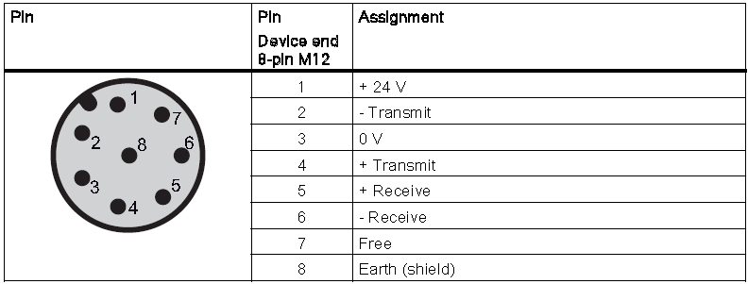

Pin at serial communication Card EL6021

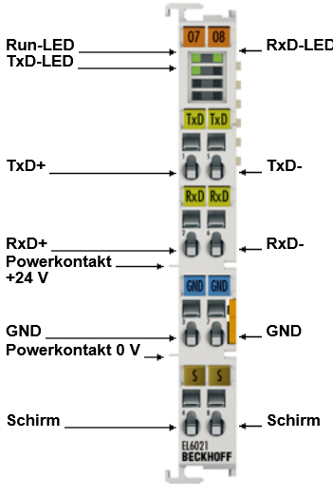

Also tested with serial communication Card EP6001



